Pixory Clone – User-Facing Pages & Features
Home Page: The homepage immediately establishes Pixory’s brand and value propositions. The top “info bar” shows trust badges like “Fast Shipping”, “30 Day Money Back Guarantee”, and “10,000+ 5 Star Reviews”[1]. A prominent hero image (e.g. photobook covers) and headline “Preserve Your Adventures in Beautiful Photobooks” appear, with a “Start My Design” call-to-action button[2]. Below this, sections highlight Pixory’s advantages – e.g. “#1 Rated in Photo Books,” craftsmanship, and emotional keepsakes – often accompanied by icons or images[3]. A step-by-step “Easy as 1,2,3” guide follows: (1) Choose your Template, (2) Upload Your Photos, (3) Customize Your Book – each with a brief description and illustration[4][5]. Next is a quality section (e.g. “Beautiful quality for beautiful moments”) and aggregated review score (e.g. “Rated 4.4/5 based on +1475 reviews”[6]). Finally, customer testimonials with user images and quotes reinforce trust[7][8]. The footer repeats trust elements (fast shipping, guarantee, 100K+ happy customers)[9][10] and lists support links (Order Help, Terms, Contact, etc.).

Example photobook cover images used in the home page hero. The homepage nav and footer (present on every page) includes links Home, Shop All, About, FAQ, My Account, social media icons, and support (FAQ, Contact)[11][12]. In summary, the Home page combines large visual banners and concise text to guide users to start designing, highlighting key features and social proof throughout[11][4].
- Header: Trust banner (Fast Shipping, Reviews, Guarantee), main nav links, cart/account links.
- Hero Section: Tagline (“Preserve Your Adventures…”), subheading, and Start My Design button[2].
- Advantages: “Pixory Advantage” features (e.g. emotional keepsakes, craftsmanship, highly rated) with images[3].
- 3-Step Guide: Illustrations and captions for “Choose Template,” “Upload Photos,” “Customize”[4][5].
- Quality & Reviews: Copy about high-quality prints with aggregate rating[6].
- Testimonials: Quotes from satisfied customers with photos[7][8].
- FAQ Snippet: A preview of the FAQ section or link to it[12].
- Footer: Trust guarantees and support links (Contact, Returns, etc.)[9][13].
Shop/Collections Page: The “Shop All” page lets users browse photobook templates. At the top it repeats the global header (trust bar and nav). Below, there are category filters/tabs: e.g. Featured, Photobooks, Magazines[14]. Beneath that is a sub-navigation for collections: “Travel,” “Yearbooks,” “Romance,” “Baby,” plus “Shop All”[15]. (Pixory uses “Travel” as a main category of templates.) Selecting a tab or category filters the displayed templates. The page shows a grid of photobook templates (each with a cover image and title). For example, the Travel category would display many destination-themed covers (e.g. “Paris 2024,” “Tokyo Trip,” etc.). Users click a template to start designing. A “Shop Most Popular” link may highlight trending designs[16]. The footer and header content remain the same. The “Shop” page essentially provides an image gallery of all available photobook templates, organized by category[14][15].
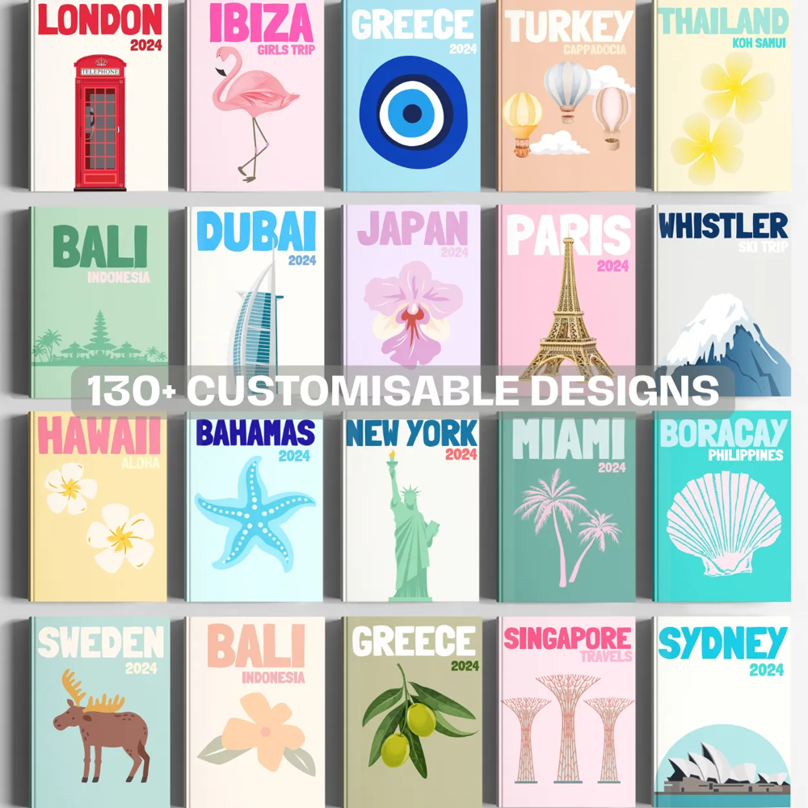
Template gallery on the Shop/Collections page (e.g. “130+ Customizable Designs” banner). Key elements:
- Category Filters: “Featured / Photobooks / Magazines” tabs[14].
- Collections Menu: Links for Travel, Yearbooks, Romance, Baby, etc.[15].
- Template Grid: Thumbnails of book covers with names; clicking one opens the designer.
- “Shop Most Popular”: A callout or section linking to best-sellers[16].
- Persistent UI: Same header footer (shipping info, links) as Home.
Category Pages (e.g. Travel, Yearbooks): Each collection page (e.g. /collections/travel) is similar to “Shop All” but scoped to that category. It has the same header and nav. For example, the Travel page shows all “travel photobook” templates. Each item displays a cover image (e.g. a landmark or vacation scene) and a template name. Clicking a template launches the editor with that cover. The FAQ indicates users “select one of our beautiful travel destination templates” to begin[17]. There may be a short category description or banner at the top. The category page may also highlight popular or new designs. Trust elements (shipping, guarantee) remain visible.
Photobook Editor (Design) Page: When the user clicks “Start My Design” or a template, they enter the interactive book editor. The first step is template selection: either a chosen template or “Start From Scratch.” Next, the user uploads photos. The UI provides a drag-and-drop or file-picker area where multiple images can be added. Once photos are uploaded, Pixory offers two modes: Auto-Create or Manual Edit[18].
- Auto-Create (“AI Smart Creator”): Clicking Auto Create runs an AI layout algorithm. Pixory “instantly organizes your photos into a cohesive, well-designed story”[19][18]. The cloned site would call a backend ML service (e.g. an Azure ML model or clustering algorithm) to place photos into the template pages. After processing, a preliminary multi-page photobook is shown for review.
- Manual Edit: Users can skip auto-create to build the book page-by-page. The editor UI shows a page layout workspace. On the canvas, users can add/edit elements:
- Photos: Drag images from an uploads panel onto pages; adjust/crop them.
- Text: Insert captions or titles with font-family, size, color choices.
- Backgrounds/Colors: Change page background colors or patterns.
- Shapes/Stickers/Clipart: Choose from preset clipart or stickers to decorate pages.
- Layout Tools: Add/remove image placeholders, align elements, reorder pages.
The FAQ emphasizes that “All of our templates are fully customisable” – customers can edit templates, colors, stickers, icons, text, etc.[20]. The editor should reflect this freedom.
The editor also includes typical UX elements: a thumbnail strip to navigate pages, undo/redo buttons, a save/preview function, and an “Add to Cart” button when the design is complete. For a UX flow example, Pixory’s how-to says after choosing a template and uploading, you “populate [the book] as the front/back cover in the editor” then choose auto or manual customization[17]. Error handling (e.g. unsupported file formats, size limits) and responsive design (for tablets) should be considered.
AI Auto-Layout Feature: This key feature (“Auto Smart Create”) should match Pixory’s. Once photos are uploaded, the user can choose the AI Create option[18]. The site says it arranges the book “in a matter of seconds”[18]. To implement this, the backend could use Python and Azure ML: for example, an ML model (or even a heuristic clustering) groups photos and assigns them to pages. Langfuse can be used to log AI model inputs and outputs for monitoring. Technically, on the front end we might show a “Creating...” spinner, then auto-populate the book with placeholder layouts and ask the user to confirm or adjust. This streamlines design for users who just want a quick book.
Shopping Cart & Checkout: Once the design is final, users “Add to Cart”. The cart page lists the photobook(s) with thumbnails, quantities, price (in INR or chosen currency). A checkout flow collects shipping information (address in India) and payment details. Payment integration can use Stripe/PayPal or a gateway (Pixory shows Visa/Mastercard logos). The Terms and Conditions mention Shopware hosting, but for our clone we’d implement standard checkout pages. The user’s preferred currency is INR by default (as project is India-focused). Order confirmation and emails are sent after successful purchase. (Pixory ships globally, but since this clone is India-centric, shipping options would be India-only or include domestic carriers.)
My Account / Login Page: Users have an account area. If not logged in, the Login page shows input fields for Email and Password, a “Login” button, and links “Forgot your password?” and “Sign Up”[21]. (Pixory’s login page follows this pattern[21].) After logging in, a user dashboard should display order history, saved projects, and account settings (not visible on Pixory, but typical). The “My Account” link in the nav toggles to “Logout” when logged in (as seen on Pixory’s pages)[22][23].
FAQ Page: The FAQ page compiles all customer questions, structured with expandable Q&A. From Pixory’s FAQ text[17][24], key questions include: “How do I order?” (explains choosing a template, then uploading with AI or manual)[17]; “How long will my order take?” (shipping times)[24]; “Do you ship internationally?” (list of countries)[25]; “How much can I customize my design?” (freedom to edit all aspects)[26]; “Dimensions of your books?” (e.g. A4, 29.7×21 cm)[27]; and “How do I get in contact?” with support email[28]. Each Q&A is a paragraph or toggle. At bottom, the footer reiterates contact/support info[29].
- Questions Covered: Ordering process (templates, AI/manual)[17]; Shipping times and regions[24]; Customization limits[26]; Book specs[27]; Contact details[28]; Order issues and refunds[30][31].
- Footer: Same trust badges and support links as other pages[29].
About Us Page: The About page presents company background and mission. In Pixory, it largely duplicates home content (same hero and trust info) but with an “About Us” heading[32]. For example, it again says “Turn Your Travels into a Story You Can Hold” with similar description[33]. It includes the “Discover the Pixory Advantage” section of emotional keepsakes and craftsmanship[34], followed by calls-to-action (“Start My Design”)[33]. It also repeats the footer badges (Fast Shipping, 100% Guarantee, 100K+ Customers)[35]. In our clone, the About page can have a brief company blurb and maybe team photos, but at minimum it should echo the header/footer and main value points as Pixory does.
- Header: Same trust banner and nav as Home[32].
- Content: Title “About Us” with the same tagline (“Preserve Your Adventures…” etc)[32]. Sections: “Pixory Advantage” icons/text[34] and a call-to-action to design. A section like “Recreate Your Photobook Today” with another Start My Design button[36].
- Footer: Trust badges (fast shipping, guarantee, customers) and support links[35].
Contact/Support Pages: Footer links point to additional pages (Order Help, Refund Policy, Contact Us, Terms, Privacy). These should be simple informational pages. For instance, Contact Us page has support email (support@pixoryofficial.com) and possibly a form. Refund Policy and Terms pages use content similar to Pixory’s (the Terms note Pixory is hosted on Shopware[37]). We would include the essential legal text and contact info on those pages, but the user asked to focus on the main user pages, so details are straightforward.

Tech Stack & Libraries
- Platform: Pixory is built on Shopware PWA (a headless e-commerce platform)[37]. Shopware PWA is based on Nuxt.js (Vue) on the front end. We will replicate Pixory’s features using React. For example, use Next.js or Create React App for the frontend, with React Router for navigation. State can be managed via Redux Toolkit (as preferred). Styling can use CSS Modules, Tailwind, or a component library (Material-UI, Ant Design) for faster development. For the editor canvas, libraries like Fabric.js, Konva, or react-pageflip could help with drag-drop and page layouts.
- Backend: Use Python (e.g. Django or FastAPI) to handle authentication, project storage, and API endpoints. The database can be PostgreSQL on Azure. The backend also integrates Shopware’s API or a custom API to fetch product/template data. For payments, integrate with Stripe/PayPal or an Indian payment gateway; Pixory’s checkout likely uses Shopware’s built-in payment connectors.
- AI & Storage: For the photo-book AI, an Azure ML or custom Python service will analyze uploaded images and generate layouts. Store user-uploaded images temporarily in Azure Blob Storage. Use Langfuse to log and monitor AI workflow (user prompts/choices and model output) as requested.
- Third-Party Services: For photo upload UI, use react-dropzone. For image editing/cropping, react-easy-crop or a similar lib. For photo storage and processing, use Azure or AWS S3 buckets. For analytics, use Google Analytics or Plausible. For emails, use SendGrid.
- Libraries Noted on Pixory: The site’s Terms explicitly states: “Our store is hosted on Shopware”[37]. The footer repeatedly shows a “Shopware PWA” logo (implying the Shopware PWA framework)[37][38]. No other third-party JS libs are directly cited in Pixory’s HTML, but they likely use modern bundles via Webpack/Vite. In our spec, citing Shopware is sufficient as the main underlying tech.
Sources: Page text and UI elements are drawn from Pixory’s live website and terms/FAQ content[1][2][17][39], as cited above, to faithfully describe each page and feature. Any library references (e.g. Shopware PWA) come from Pixory’s own disclosures[37]. The spec translates Pixory’s design into the requested React/Python/Azure tech stack while noting Pixory’s approach where evidenced.

[1] [2] [3] [4] [5] [6] [7] [8] [9] [10] [11] [12] [13] [19] [22] Pixory
https://www.pixoryofficial.com/
[14] [15] [16] [39] Pixory
https://www.pixoryofficial.com/collections/all
[17] [18] [20] [24] [25] [26] [27] [28] [29] [30] [31] FAQ
https://www.pixoryofficial.com/FAQ/
[21] Pixory
https://www.pixoryofficial.com/login
[23] [37] [38] Terms and Conditions
https://www.pixoryofficial.com/Terms-and-Conditions/
[32] [33] [34] [35] [36] About
https://www.pixoryofficial.com/About/

